Clinical Approach to Sleep Management

DSM-5 Criteria for Insomnia Disorder

Difficulty with sleep – Persistent difficulty with one or more of the following:

Initiating sleep

Maintaining sleep (frequent awakenings or trouble returning to sleep)

Early-morning awakening with inability to return to sleep

Impairment or distress – Causes significant distress or impairment in social, occupational, or other important areas of functioning.

Frequency & Duration – Occurs at least 3 nights per week for at least 3 months.

Adequate opportunity for sleep – Sleep difficulties persist despite sufficient opportunities for sleep.

Not better explained by – Another sleep disorder, medical condition, substance use, or mental disorder. Add specifier code 780.52 (G47.00) for any associated condition.

Sleep History & Initial Assessment
- Ask patients to maintain a sleep diary to track patterns and identify potential issues.
- Assess sleep and waking symptoms, considering medical, psychiatric, and other sleep disorders such as obstructive sleep apnea, restless leg syndrome, or narcolepsy. .
- Review medications, past sleep treatments, and ROS (Review of Systems).
- Determine intrinsic circadian rhythm (early bird vs. night owl).
- Evaluate shift work: type, duration, and transitions between shifts.
- Understand lifetime sleep patterns and how sleep is when unconstrained.

Sleep Questionnaires
- Insomnia Severity Index (ISI)
  - 7-item scale evaluating severity over two weeks.
  - ISI Questionnaire
- Pittsburgh Sleep Quality Index (PSQI)
  - 19 questions measuring sleep quality, latency, and duration over one month.
  - PSQI Questionnaire
- Morningness–Eveningness Questionnaire (MEQ)
  - Identifies circadian rhythm for peak alertness.
  - MEQ Questionnaire
- Epworth Sleepiness Scale
  - Measures daytime sleepiness in various activities over two weeks.
  - Epworth Questionnaire
- STOP-BANG Questionnaire
  - Assesses sleep apnea risk (Low 0-2, Moderate 3-4, High 5-8).
  - STOP-BANG Questionnaire
- Dysfunctional Attitudes & Beliefs about Sleep
  - 16 questions to guide CBT-I and track patient progress with treatment
  - DBAS Questionnaire

Cognitive Behavioral Therapy for Insomnia (CBT-I)
- 3P Model (Spielman et al., 1987)
  - Predisposing: Genetics, medical/psychological conditions.
  - Precipitating: Stress, environment, behaviors.
  - Perpetuating: Chronic stress, maladaptive coping, cognitive factors.
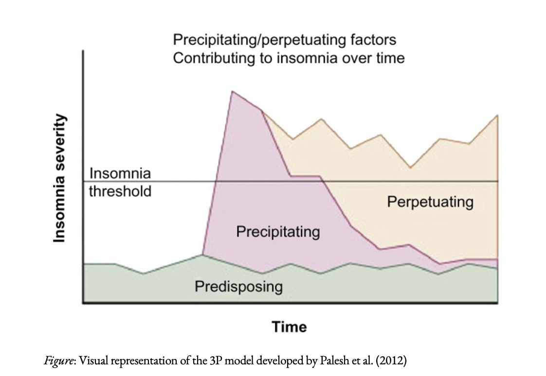
- Two-Process Model of Sleep Regulation
  - Process S (Homeostatic): Genetics influence sleep duration. Sleep need is defined by the absence of daytime fatigue, varying per individual. Sleep drive builds from wakefulness until sleep.
  - Process C (Circadian Rhythm): Regulated by light exposure, sleep schedule, and melatonin.
- Sleep Restriction Therapy
  - Limits time in bed to actual sleep time.
  - Sleep efficiency >85%: advance bedtime by 30 minutes.
  - Use cautiously in BPD patients.

Complementary & Behavioral Sleep Interventions
- Light Therapy: Exposure to morning light for delayed sleep phase; evening light for advanced sleep phase.
- Relaxation Techniques: Breathing exercises, meditation, progressive muscle relaxation.
- Constructive Worrying: Technique to manage worrying at bedtime.
- Sleep Hygiene Tips:
  - Maintain a consistent sleep schedule (7 days a week).
  - Avoid caffeine after 1 PM, limit alcohol, and eliminate naps.
  - Create a dark, cool sleeping environment.
  - Bed is only for sleep & intimacy—no screens, pets, or distractions.

Medications for Chronic Insomnia: Guidelines
- AASM (2017) & VA/DoD (2025): CBT-I & sleep hygiene = first-line treatment.
American Academy of Sleep Medicine Clinical Practice Guideline for the Pharmacologic Treatment of Chronic Insomnia in Adults (2017)
https://jcsm.aasm.org/doi/10.5664/jcsm.6470

All pharmacological recommendations graded as WEAK evidence based on systematic review. AASM recommends CBT-I as first line treatment d/t strong evidence.
Sleep Maintenance Insomnia |  | Sleep Onset Insomnia | Recommended Against
Suvorexant  Eszopiclone  Zolpidem  Temazepam  Doxepin |  | Ramelteon  Eszopiclone  Zaleplon  Zolpidem  Triazolam  Temazepam | Trazodone  Tiagabine  Diphenhydramine  Melatonin  Tryptophan  Valerian
Drugs with Black Box Warnings: Eszopiclone, Zaleplon, Zolpidem, Triazolam, Temazepam, Doxepin, Quetiapine, Diazepam, Lorazepam, Alprazolam, Trazodone
Suvorexant: Narcolepsy is a contraindication.

VA/DoD Clinical Practice Guidelines: The Management of Chronic Insomnia Disorder and Obstructive Sleep Apnea Pharmacotherapy and OTC Treatment for Chronic Insomnia (2025) https://www.healthquality.va.gov/guidelines/CD/insomnia/index.asp#:~:text=The%20guideline%20describes%20the%20critical,of%20patients%20with%20Insomnia/OSA.

The VA and DoD recommend behaviorally-based approaches such as CBT-I as first line treatments but recognize indications for short-term pharmacotherapy
Suggested | Insufficient Evidence for or Against | Suggested AGAINST | Recommended AGAINST
Low dose Doxepin  Zolpidem  Zaleplon  Eszopiclone  Auricular acupuncture with seed and pellet | Ramelteon  Suvorexant | Quetiapine  Diazepam  Lorazepam  Alprazolam  Trazodone  Diphenhydramine  Melatonin  Chamomile  Valerian  Alpha-stim  Cranial electrical stimulation | Kava: FDA advisory about the risk of liver damage or death
Drugs with Black Box Warnings: Eszopiclone, Zaleplon, Zolpidem, Triazolam, Temazepam, Doxepin, Quetiapine, Diazepam, Lorazepam, Alprazolam, Trazodone
Suvorexant: Narcolepsy is a contraindication.

Recommended Resources
- Devices: Light therapy lamps, sleep headphones, masks, trackers–Apple Watch, Whoop, Fitbit, Samsung Galaxy Watch, Oura Ring, GarminVenu3
- Journal Articles:
  - Watson, N. F., Benca, R. M., Krystal, A. D., McCall, W. V., & Neubauer, D. N. (2023). Alliance for Sleep Clinical Practice Guideline on Switching or Deprescribing Hypnotic Medications for Insomnia. Journal of Clinical Medicine, 12(2493). https://pmc.ncbi.nlm.nih.gov/articles/PMC10095217/pdf/jcm-12-02493.pdf
- Books:
  - Say Goodnight to Insomnia (Gregg Jacobs, PhD)
  - The Sleep Prescription (Aric Prather, PhD)
  - No More Sleepless Nights (Peter Hauri, MD)
  - Quiet Your Mind & Get to Sleep (Colleen Carney, PhD)
- Websites:
  - Patient & Clinician Handouts: VA/DOD Clinical Practice Guidelines
  - Patient Infographic: National Institute on Aging: Better Sleep
  - Mobile App for Patients: CBT-I Coach Mobile App
  - CE Opportunity for Providers: CBT-I Web
  - Patient Worksheets: Dr. Colleen Carney

Key Takeaways for Clinicians
- Screen for sleep disorders: "How well are you sleeping?" "Do you wake up rested?"
- Use questionnaires & sleep diaries for assessment.
- Prioritize non-pharmacological interventions (CBT-I, stimulus control, sleep hygiene).
- Consider pharmacotherapy only when necessary, reviewing contraindications.
- Familiarize with at least one online or mobile CBT-I resource for patient support.

Final Thought: Prioritizing behavioral interventions for sleep disorders leads to long-term improvements without reliance on medication. CBT-I remains the gold standard.

